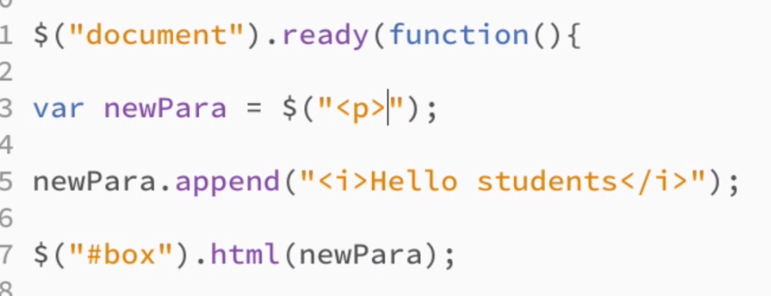

* In the above Code snippet, IN CASE, if a PARAGRAPH tag is present in the HTML, then that existing PARAGRAPH will be REPLACED WITH THE ONE CODED ABOVE
* Now, if we see $(“P”)🡪 Then WE ARE EXTRACTING CONTENT from that
* If WE SEE $(“<P>”)🡺 Then we are CREATING THE TAG.

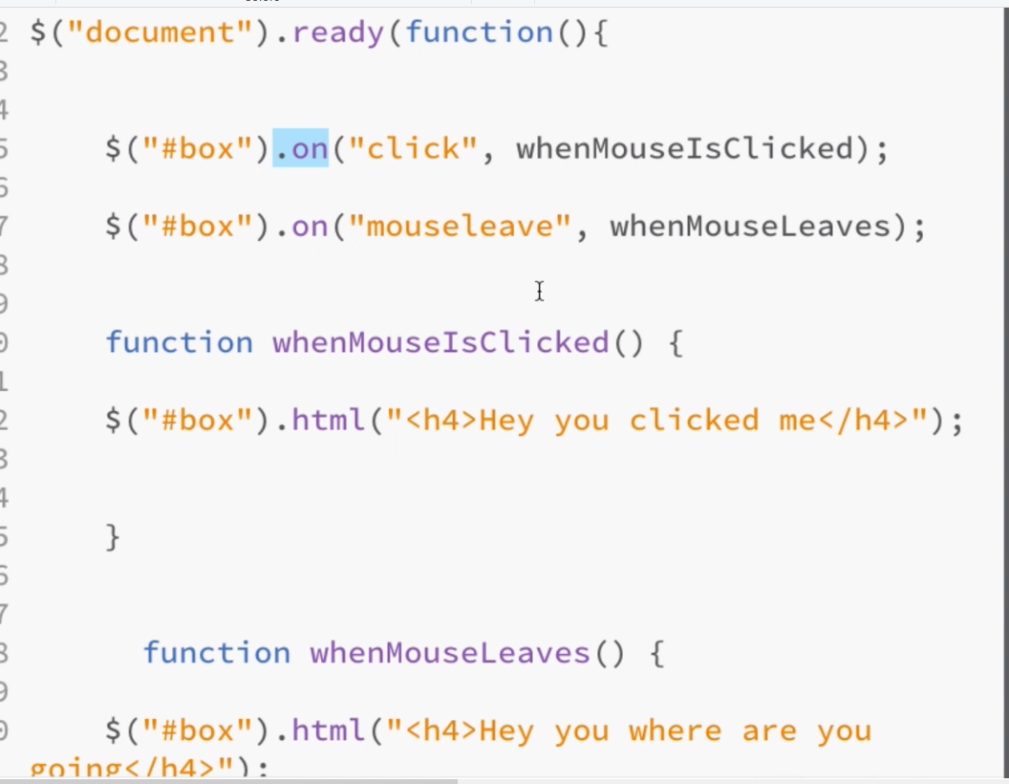

* The Above Code snippet is for Mouse Events
* html() function
  + The html() method sets or returns the content (innerHTML) of the selected elements.
  + When this method is used to return content, it returns the content of the FIRST matched element.
  + When this method is used to set content, it overwrites the content of ALL matched elements.
  + Tip: To set or return only the text content of the selected elements, use the text() method.

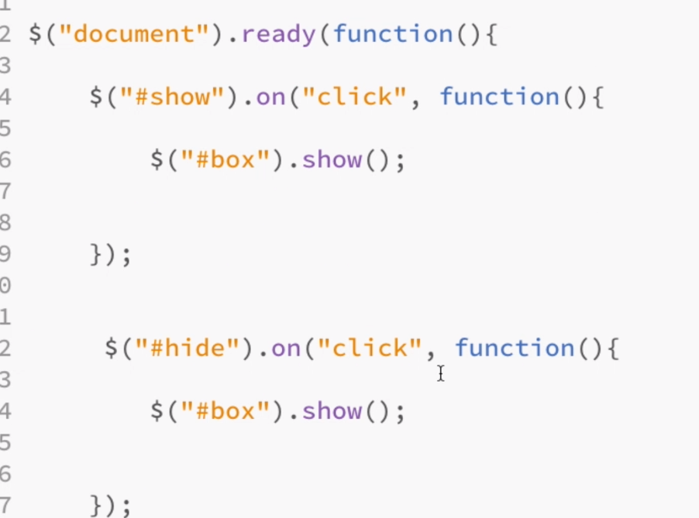

* Above Code snippet is for SHOWING and HIDING the html

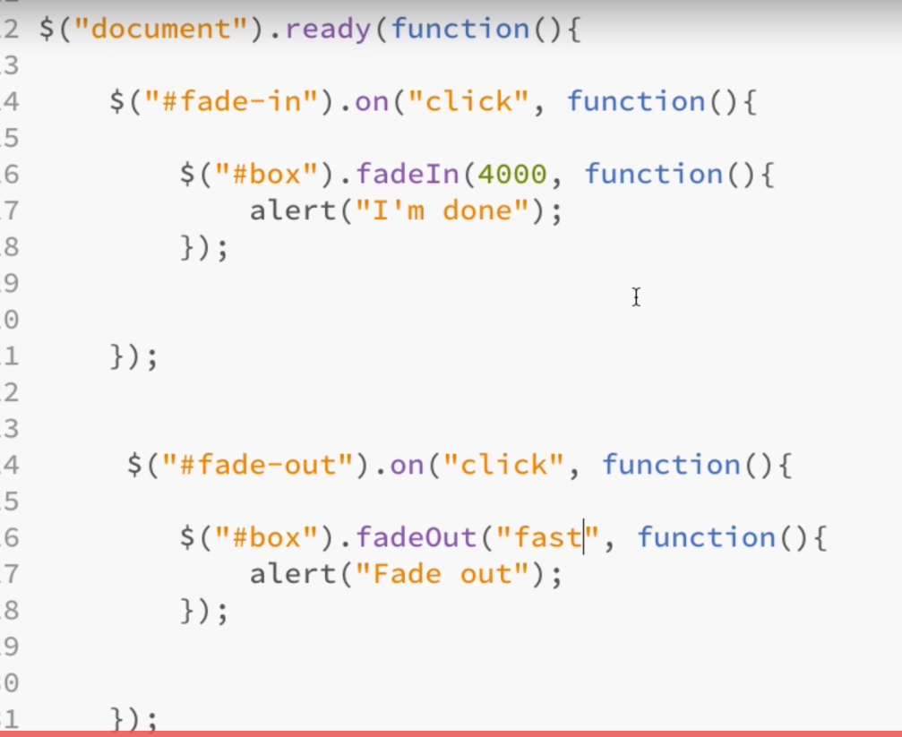

For FADE IN and FADE OUT

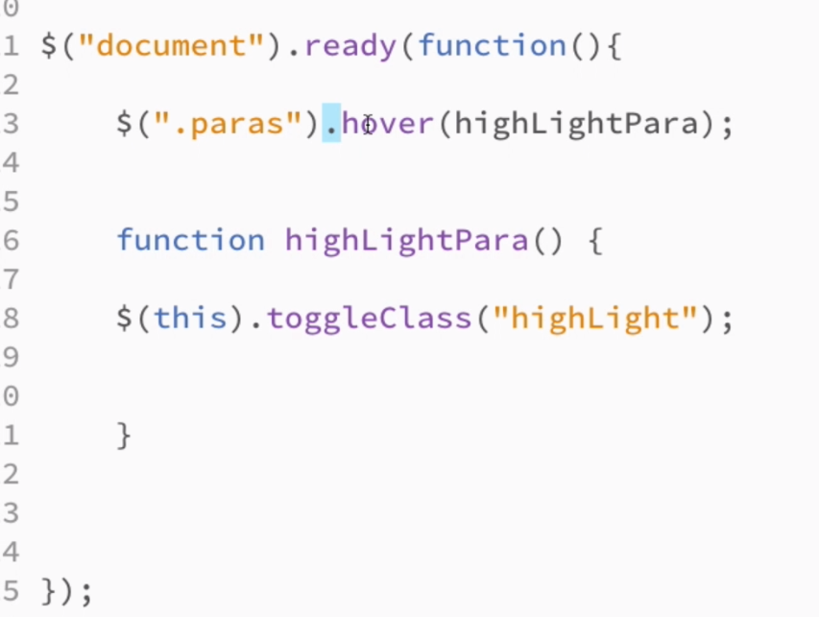

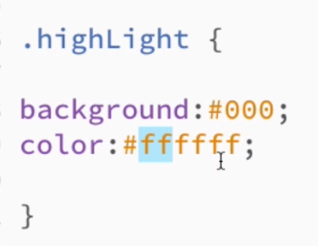

Hover over effect

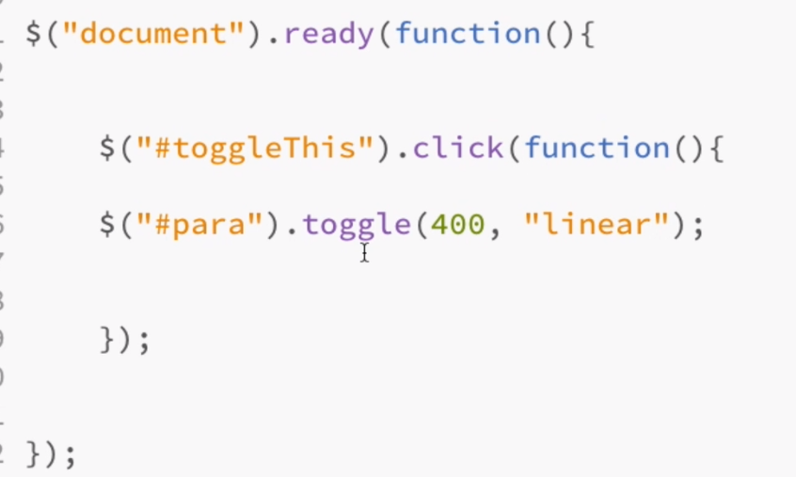

Toggle Function

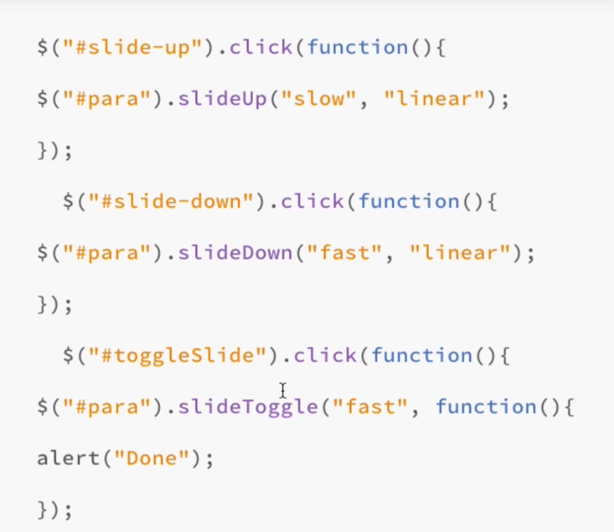

Slide up and Slide Down

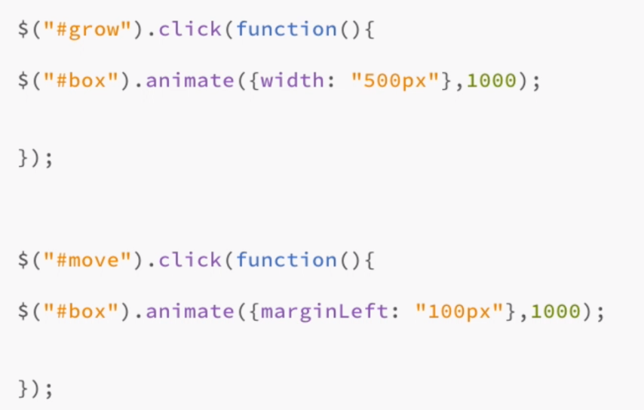

Custom Animations Grow, Move

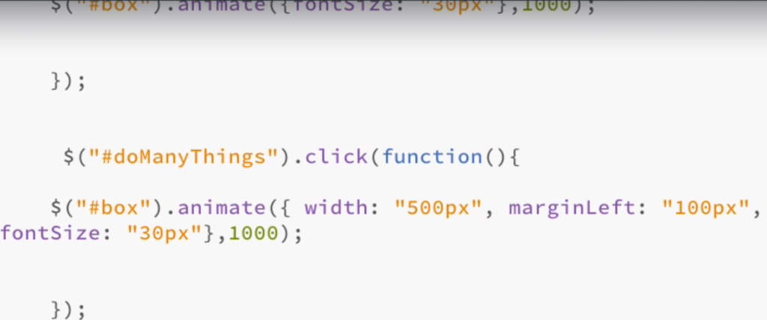

Custom Animations Do Many things, Font Size

# Selectors

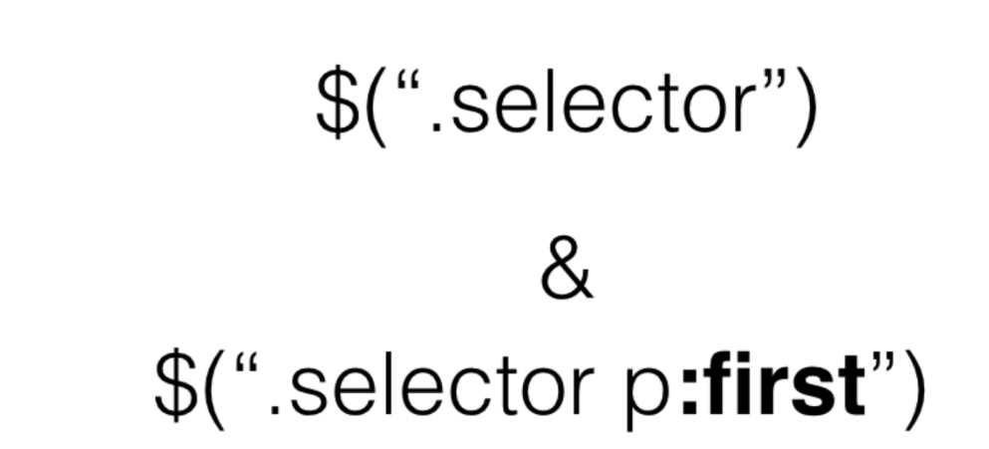

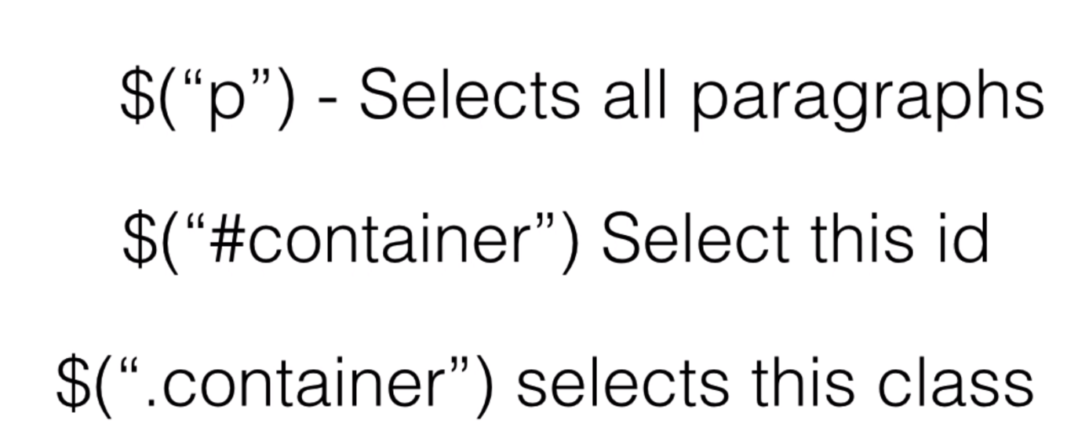

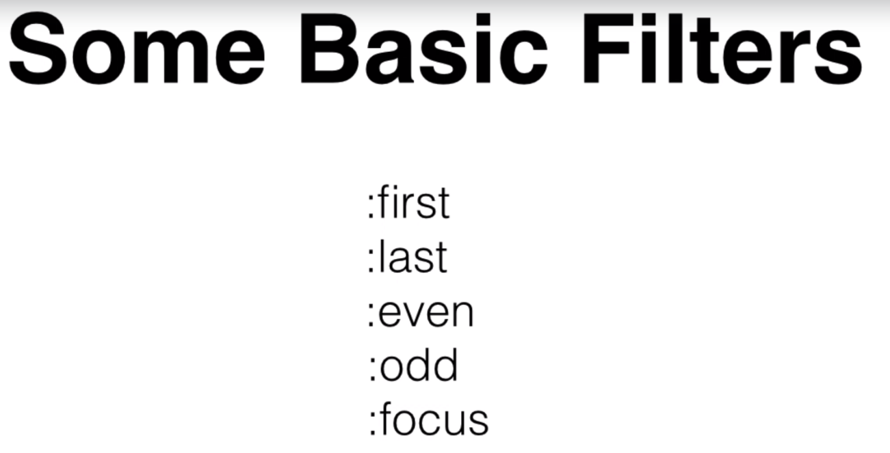

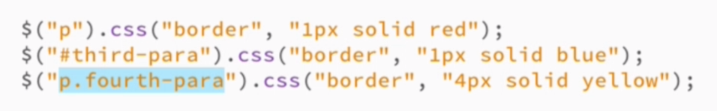

Advanced Filters:

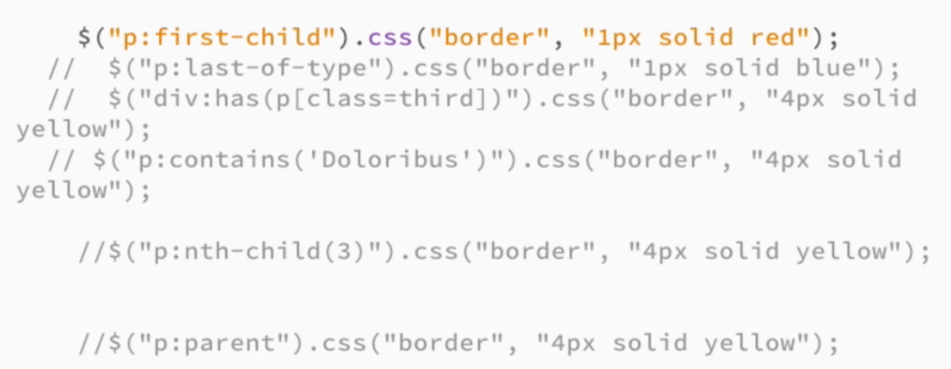

# Adding Content:

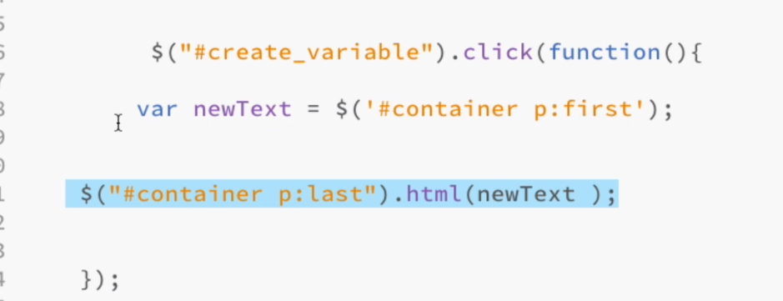

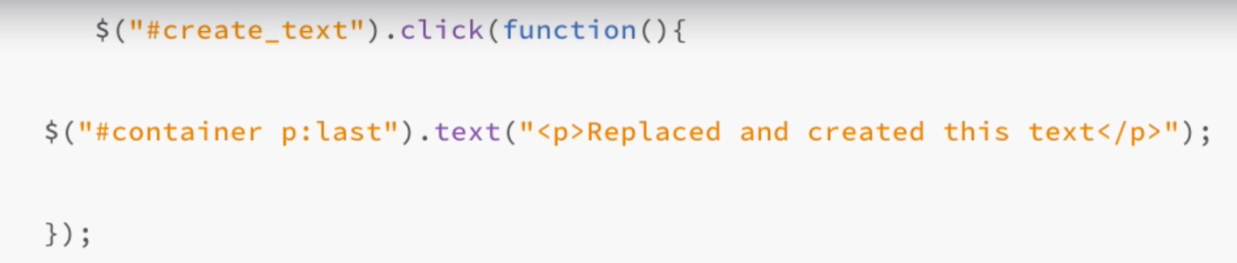

O/P: for text() function

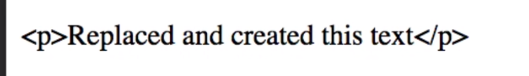

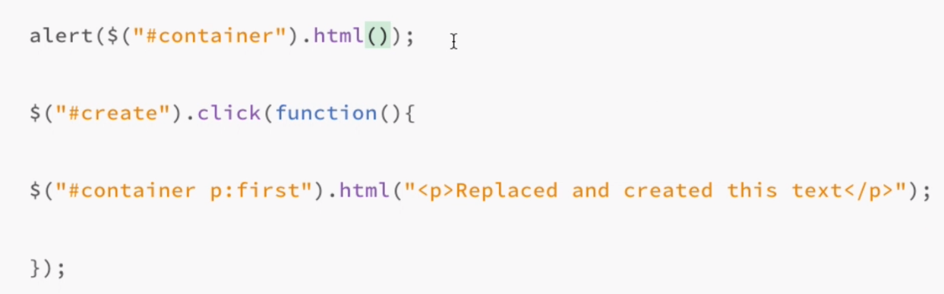

# Append Content:

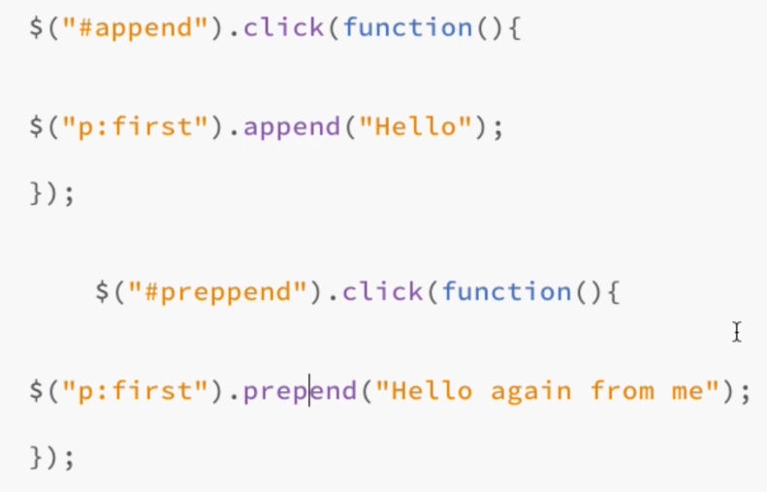

# Inserting Content – Way 2:

## Before appending

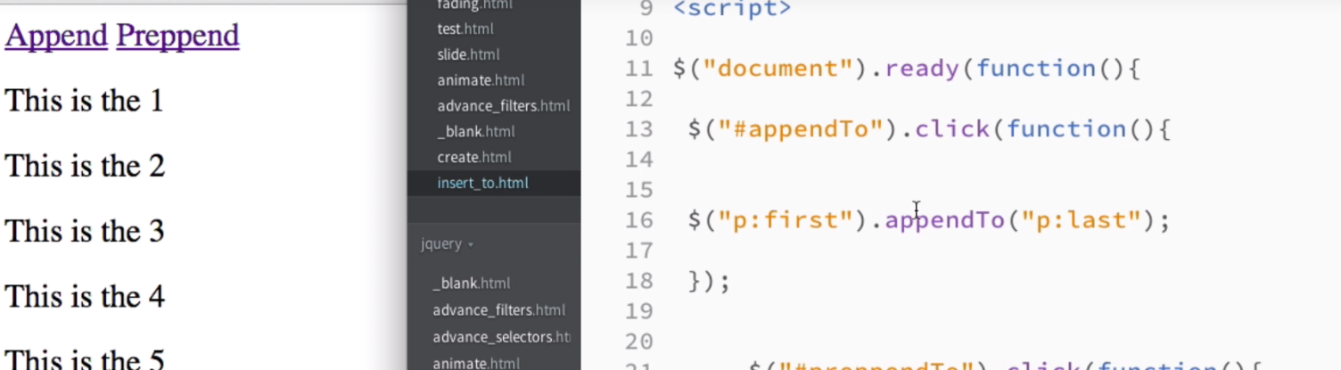

## Appending Code:

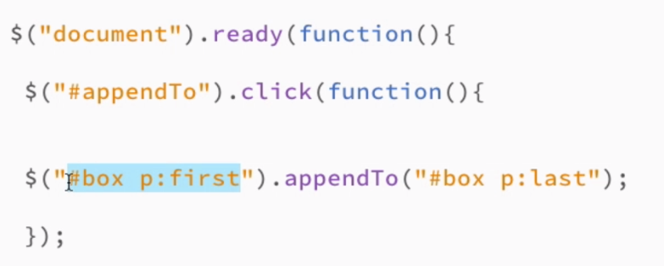

O/P:

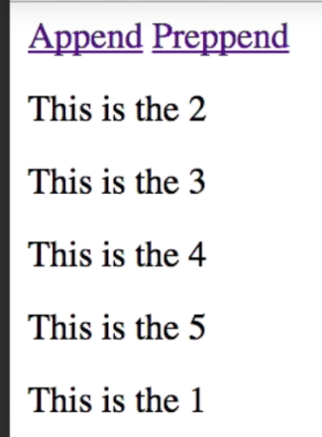

# PrePendTo:

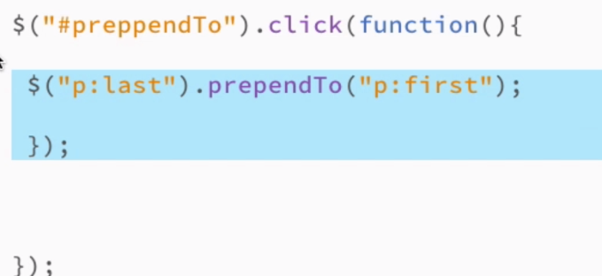

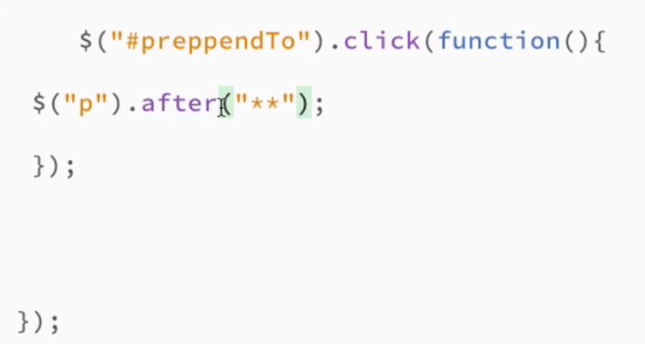

O/P:

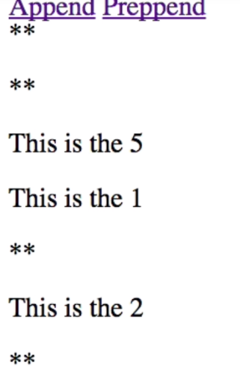

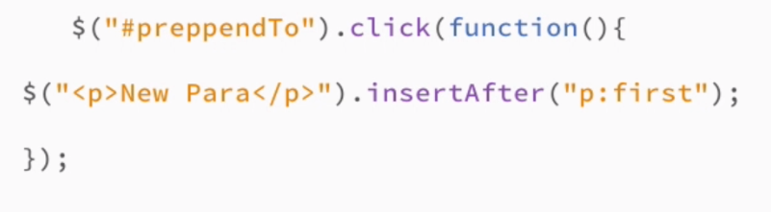

# Modifying Content:

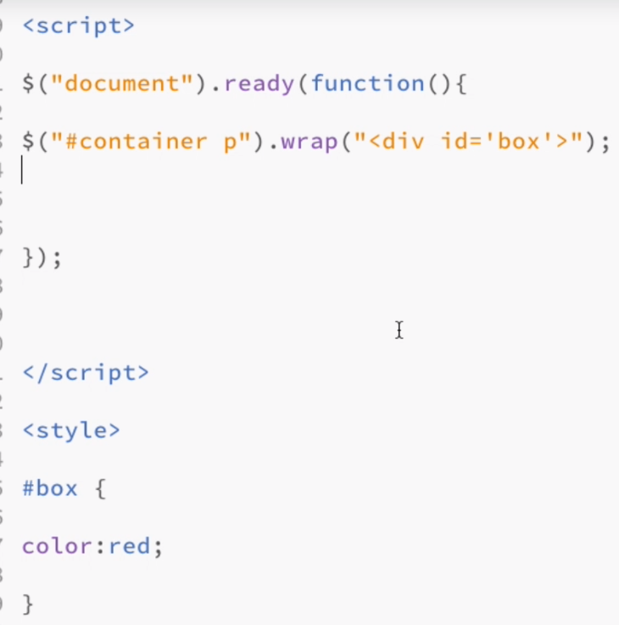

O/P:

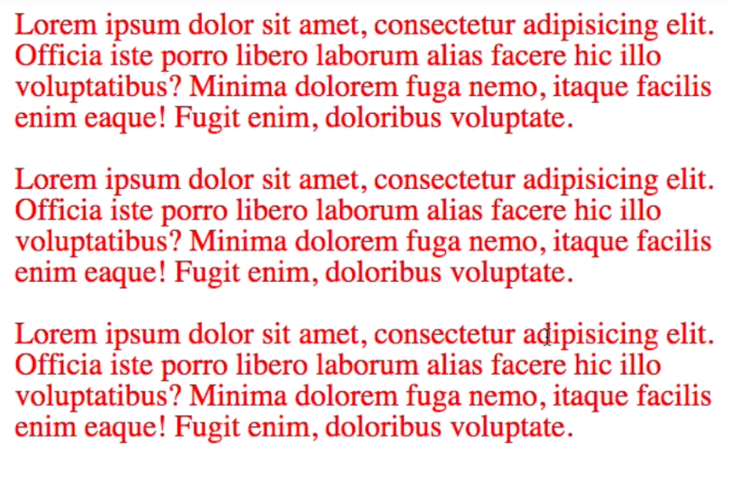

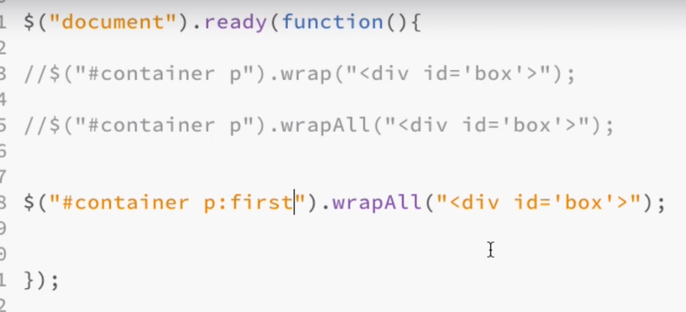

O/P:

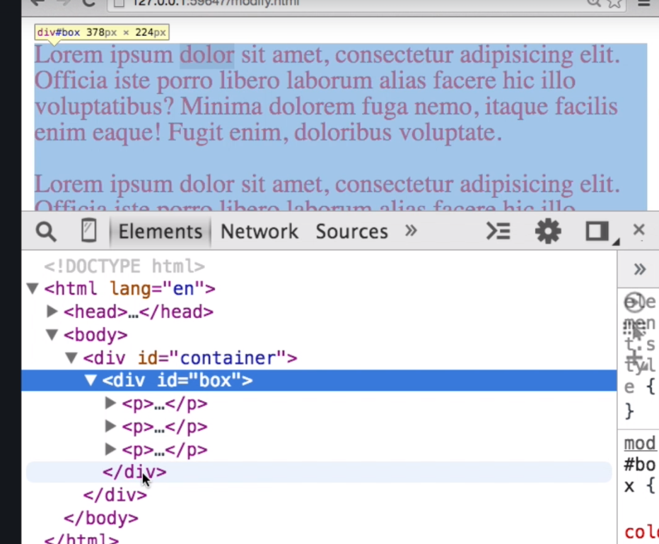

# Clear Contents:

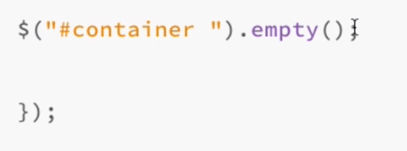

# Removing Contents:

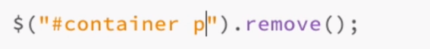

# Replace:



O/P:

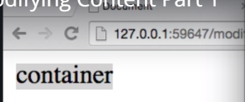

# Replace With



# CSS Manipulations [Add Class, Remove Class, Toggle Class]:

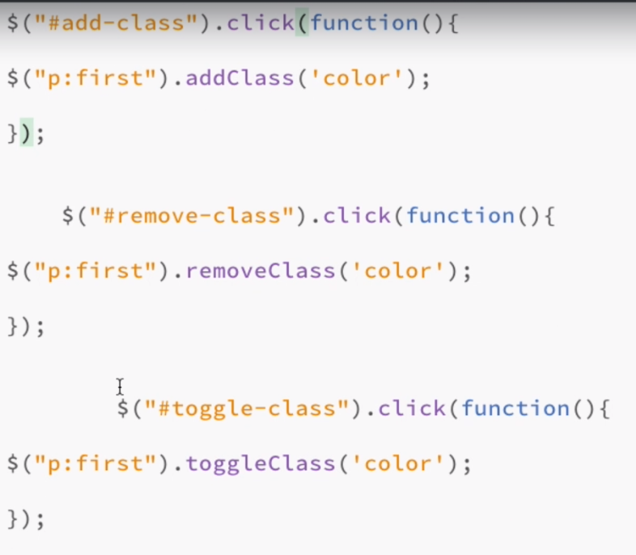

# Increase Font Size:

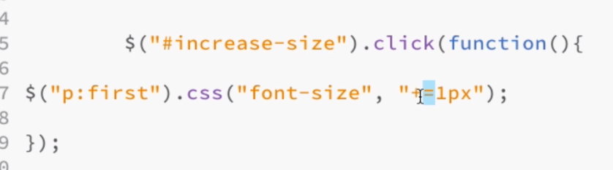

# Navigation DOM:

